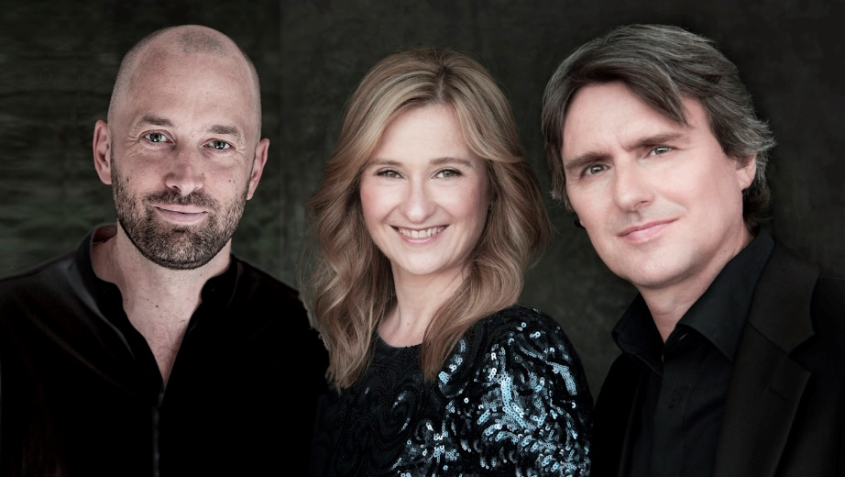
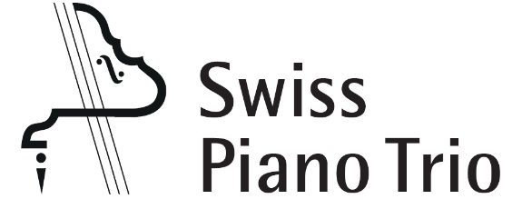

The Swiss Piano Trio
Martin Lucas Staub, piano
Angela Golubeva, violin
Franz Ortner, violoncello

Founded in 1998, the Swiss Piano Trio has gained since a remarkable reputation among both experts and the public as an ensemble of outstanding balance and technical perfection whose interpretations electrify with emotional power and their rich and colourful sound. It is therefore not surprising that the US-magazine Fanfare described the Swiss Piano Trio as „one of the very top piano trio ensembles on today’s stage“.

The Swiss Piano Trio is first-prize winner of the International Chamber Music Competition in Caltanissetta (Italy) 2003 and the International Johannes Brahms Competition (Austria) 2005; during the same year, the trio was honoured with the Swiss Ambassador’s Award in the Wigmore Hall London. The ensemble received valuable artistic advice from Menahem Pressler (Beaux Arts Trio), Valentin Berlinsky (Borodin Quartet), the Altenberg Trio (Vienna), the Trio di Milano and the Amadeus Quartet.

The Swiss Piano Trio has given concerts in 45 countries on all continents. The musicians performed in renowned halls such as the Great Hall of Moscow Conservatory, the Tonhalle Zurich, the Victoria Hall Geneva, the KKL Lucerne, the Wigmore Hall London, the Concertgebouw Amsterdam, the Teatro Teresa Carreño Caracas, the Teatro Coliseo Buenos Aires, the QPAC Brisbane, and the National Center for the Performing Arts in Beijing. In performances of various triple concertos, the Swiss Piano Trio appears as a soloists’ ensemble together with orchestras such as the Scottish Chamber Orchestra, the Russian National Orchestra, the Athens State Orchestra, the Zurich Chamber Orchestra, the Bern Symphony Orchestra, the Musikkollegium Winterthur, the Orchestre Philharmonique Royal de Liège, the Christchurch Symphony Orchestra, the Queensland Orchestra in Brisbane, and many more. The ensemble has worked with conductors such as Thomas Zehetmair, Mario Venzago, Johannes Fritzsch, Loukas Karytinos, Pascal Rophé and others. The Swiss Piano Trio regularly accepts invitations to perform at renowned festivals such as the Menuhin Festival Gstaad, the Ottawa Chamberfest, Kuhmo Chamber Music, the Canberra International Music Festival, the Esbjerg International Chamber Music Festival, the Båstad Chamber Music Festival, the Festival of the Sound or the Chamber Music Festival Schloss Laudon in Vienna. In addition, the Swiss Piano Trio gives masterclasses in many countries.

Numerous radio, TV and CD recordings with works by Mozart, Mendelssohn, Robert and Clara Schumann, Tchaikovsky, Dvořák, and Eduard Franck, as well as piano trios by the Swiss composers Paul Juon, Frank Martin and Daniel Schnyder document the artistic activities of the ensemble. The six-part complete edition of Beethoven's works for piano trio, including the Triple Concerto together with the Zurich Chamber Orchestra and Beethoven’s own version of his second symphony for piano trio, was recently completed. Like all other previously released recordings, this Beethoven-Edition has already won several awards. Since 2011, the Swiss Piano Trio has been releasing its recordings on the audite label.

The ensemble is also strongly committed to contemporary Swiss music. Alongside regular performances of works by Swiss composers, the Swiss Piano Trio has commissioned compositions by Martin Wettstein, Daniel Schnyder, Francesco Hoch, Florian Walser, Martin Schlumpf, Richard Dubugnon and Matthias Roth.

Further information on www.swisspianotrio.com

